Instructions for Determining LCMRLs using RStudio

# Introduction

This document describes the procedure for calculating the Lowest Concentration Minimum Reporting Level (LCMRL) using the free cross-platform software RStudio. The instructions are divided into three parts: 1.) downloading and testing the required software, 2.) using the LCMRL program within RStudio to calculate LCMRLs, and 3.) the experimental procedure for collecting LCMRL data.

# Definitions

## R

Formally called *The R Project for Statistical Computing*, R is a free software environment for statistical computing and graphics.

## RStudio

RStudio is an integrated development environment (IDE) for R. It is also free software. Although LCMRLs can be calculated in R, RStudio is a more user friendly interface for downloading packages and running statistical programs.

## Github

Github is public domain, code hosting platform. EPA has selected Github to distribute the LCMRL program.

## Packages

Packages are shared code available from public domain websites such as the R Project website and Github for performing statistical functions in R. To configure R for calculating LCMRLs, the package named *LCMRL* is required. This package is available as a free download from the EPA page on the Github website. The source code developed by EPA for the LCMRL calculations is embedded in the *LCMRL* package.

## Dependencies

A dependency is a package that is linked to a primary package and includes functions required by the primary package. To configure R for calculating LCMRLs, the primary package *LCMRL* requires the dependencies *lattice* and *car*.

## Input File for LCMRL Data

The input file is a Microsoft Excel comma separated values (.csv) file containing the results of the laboratory reagent blank (LRB) and laboratory fortified blank (LFB) samples for a partial or completed LCMRL procedure. These data must be arranged in a specific format within the .csv file that is compatible with the LCMRL program (Sect. 4.2).

## Output Files

There are two output files. The LCMRL program writes the LCMRL results to a Microsoft Excel .csv file in tabular format and writes the LCMRL graphs in PDF format.

## LCMRL Scripts

Scripts are command lines entered by the user into RStudio that select the input file and execute the code for calculating LCMRLs and constructing the LCMRL graphs. The scripts accept arguments called “modeling parameters”. The default modeling parameters generate LCMRLs meeting the definition of the LCMRL published in EPA drinking water methods (Sect. 2.13).

## Source Code

The algorithms for calculating LCMRLs contained in the *LCMRL* package. Throughout these instructions, we refer to the source code as the “LCMRL program”.

## Test Data

An input file that is used to verify proper download and operation of the LCMRL program within RStudio. The test data file is embedded in the *LCMRL* package.

## Laboratory Fortified Blank (LFB)

The LFB is an aliquot of reagent water, containing method preservatives, to which known quantities of the method analytes are added. The concentration of the analytes in an LFB is called a “spiking level” in the terminology of the LCMRL procedure (Sect. 6).

## Laboratory Reagent Blank (LRB)

The LRB is an aliquot of reagent water containing the method preservatives. LRBs are used to collect data for the required “zero spiking level” in the LCMRL procedure (Sect. 6).

## Lowest Concentration Minimum Reporting Level (LCMRL)

The single-laboratory LCMRL is the lowest spiking concentration such that the probability of spike recovery in the 50% to 150% range is at least 99%.1

# Creating the R Computing Environment for Calculating LCMRLs

The LCMRL program, or source code, for calculating LCMRLs runs within the R statistical computing environment. Two free software downloads, R and RStudio, are required to create this computing environment. A free package, *LCMRL,* is required to configure R for calculating LCMRLs. The source code (Sect. 2.9) and test data file (Sect 2.10) are incorporated into the *LCMRL* package.

## R Download

Go to <https://cloud.r-project.org/>. This link will take you to a webpage titled *The Comprehensive R Archive Network* (CRAN)*.* Follow the links to download the most recent version of R appropriate for your operating system. For Microsoft Windows® operating systems, an executable file (*.exe) will download to your computer. Install the R software following the steps for your operating system.

## RStudio Download

Go to the *Download RStudio* webpage, <https://rstudio.com/products/rstudio/download/>. Follow the links for the RStudio Desktop open source license. Locate and download the appropriate version of RStudio for your operating system. For Microsoft Windows® operating systems, an executable file (*.exe) will download to your computer. Install the RStudio software following the steps for your operating system.

## Downloading R and RStudio to Secure Networks

The steps for downloading R and RStudio described above may not be appropriate for secure networks. Consult with your IT department for permissions and polices for obtaining these applications.

## Download Required Dependencies

Start RStudio. It is not necessary to start R. The RStudio console will appear with a message (version number and disclaimer) followed by a command prompt indicated by “>” (Figure 1).

Under the **Tools** dropdown menu, select **Install Packages**. In the **Install Packages** dialog box, verify that the **Install From** drop-down list is set to “Repository CRAN”. In the **Packages** text-input box, type *lattice*. The **Install dependencies** check box must be selected. Click the **Install** button. Ignore the warning message that *Rtools* is required and should be downloaded – if it appears. The following message will be written to the RStudio console indicating a successful download: “package ‘lattice’ successfully unpacked and MD5 sums checked”.

In the **Packages** text-input box, type *car*. The **Install dependencies** check box must be selected. Click the **Install** button. Ignore the warning message that *Rtools* is required and should be downloaded – if it appears. A series of messages will be written to the RStudio console ending with the line: “package ‘car’ successfully unpacked and MD5 sums checked”.

## Download the *LCMRL* Package from Github

From the LCMRL Calculator page on Github (<https://github.com/USEPA/LCMRL_calculator>), download the appropriate *LCMRL* package for your operating system:

For Windows: LCMRL_1.0.9.zip

For Mac OSX: LCMRL_1.0.9.tgz

Choose or create a folder to save the package. The contents of the folder will be similar to the image below.

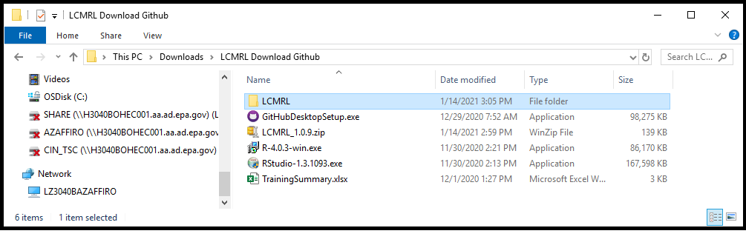

## Install the *LCMRL* Package into RStudio

Under the **Tools** dropdown menu, select **Install Packages**. Select “Package Archive File (.zip; tar.gz)” in the **Install From** drop-down list. Click the **Browse** button to open the **Select Package Archive** dialog box. Locate and click on the *LCMRL* package file: LCMRL_1.0.9.zip or LCMRL_1.0.9.tgz. Click the **Open** button in the dialog box. The **Select Package Archive** box will close and the *LCMRL* package file will appear in the **Install Packages** dialog box:

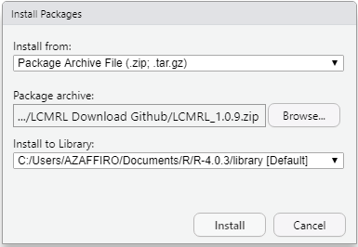

Click the **Install** button. A message will be written to the RStudio console ending with the text: “package ‘LCMRL’ successfully unpacked and MD5 sums checked”.

## Alternate Procedure for Installing the *LCMRL* Package from Github

If the *LCMRL* package does not install successfully, follow the steps in this section. A third dependency “*devtools*” must be downloaded from the CRAN prior to downloading the *LCMRL* package.

Under the **Tools** dropdown menu, select **Install Packages**. In the **Install Packages** dialog box, verify that the **Install From** drop-down list is set to “Repository CRAN”. In the **Packages** text-input box, type *devtools*. The **Install dependencies** check box must be selected. Click the **Install** button. The following message will be written to the RStudio console indicating a successful download: “package ‘devtools’ successfully unpacked and MD5 sums checked”. Locate *devtools* under the **Packages** tab in the console. Click in the check box. A checkmark will appear in the box and the RStudio console will display the script library(devtools).

From the LCMRL Calculator page on Github (<https://github.com/USEPA/LCMRL_calculator>), download the following package:

LCMRL_1.0.9.tar.gz

Under the **Tools** dropdown menu, select **Install Packages**. Select “Package Archive File (.zip; tar.gz)” in the **Install From** drop-down list. Click the **Browse** button to open the **Select Package Archive** dialog box. Locate and click on the *LCMRL* package file: LCMRL_1.0.9.tar.gz. Click the **Open** button in the dialog box. The **Select Package Archive** box will close and the *LCMRL* package file will appear in the **Install Packages** dialog box:

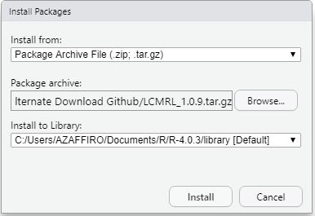

Click the **Install** button. A series of messages appear in the RStudio console ending in: “Done (LCMRL)”. If RStudio returns an error message, please contact EPA TSC for assistance (Wendelken.Steve@epa.gov).

## Activate the Statistics Packages

Each time RStudio is opened, the statistics packages must be activated to load the LCMRL program. Do this prior to verifying operation of the calculator (Sect. 3.9)

Select the **Packages** tab in the field at the lower right of the RStudio console (Figure 2). Find *lattice* and *LCMRL* in the list and click on the check box for each. A checkmark will appear in the boxes and the RStudio console will display the script library(package) as each package is selected, where package equals *lattice* or *LCMRL* (Figure 2).

### Verify Operation for Calculating LCMRLs

At the command prompt type or paste the script LCMRL.Values() followed by a carriage return. This command calculates LCMRLs for five analytes using the test data embedded in the *LCMRL* package. After processing is complete, a message appears in the RStudio console giving the name of the .csv file containing the calculated LCMRLs and the location of the file (Figure 3).

Locate and open the LCMRL output file. Verify that the LCMRLs in Column B and the messages in Column G are identical to those listed in Table 1. Expand Column G to view the full message. Ignore the information in the other columns. Two of the analytes, Analyte 2 and Analyte 4, should give error messages in Column G. These represent the two possible error messages for an incomplete LCMRL determination:

* For Analyte 2, an estimated LCMRL of 1.3 ng/L is reported with the message, “Lower spiking level needed to bracket LCMRL”. See Section 6.2.3 for more information on this circumstance.
* For Analyte 4, the LCMRL is reported as “0” with the message, “LCMRL is above highest spiking level”. See Section 6.2.4 for more information on this circumstance.

### Verify Operation for Printing LCMRL Graphs

At the command prompt, type or paste the script LCMRL.Graphs() followed by a carriage return. After processing is complete, the RStudio console displays a message giving the name of the PDF containing the LCMRL graphs and the location of the file (Figure 4).

Open the output file and compare the PDF contents to Figure 5. Two graphs for each analyte should appear: the QC Interval Coverage Plot and the LCMRL Plot. Both graphs for Analyte 2, should display this error message: “LCMRL is Below Lowest Non-Zero SL”. “SL” = spiking level”. For Analyte 4, no graphs will appear in the PDF output as observed in Figure 5.

# Running the LCMRL Program for User Data

## Collect LCMRL Data

Follow the procedure in Section 6 to collect LCMRL data. Arrange the data in a properly formatted input file (Sect. 4.2).

## Creating the Input File for LCMRL Data

The input files are expected to be Microsoft Excel .csv files with a header in the first row. LCMRL results are arranged in rows as illustrated in the image below. The method analytes and concentration levels can be inserted in any order, or you may enter a complete set of LCMRL data for an analyte before proceeding to the next analyte in subsequent rows.Negative values are allowed.

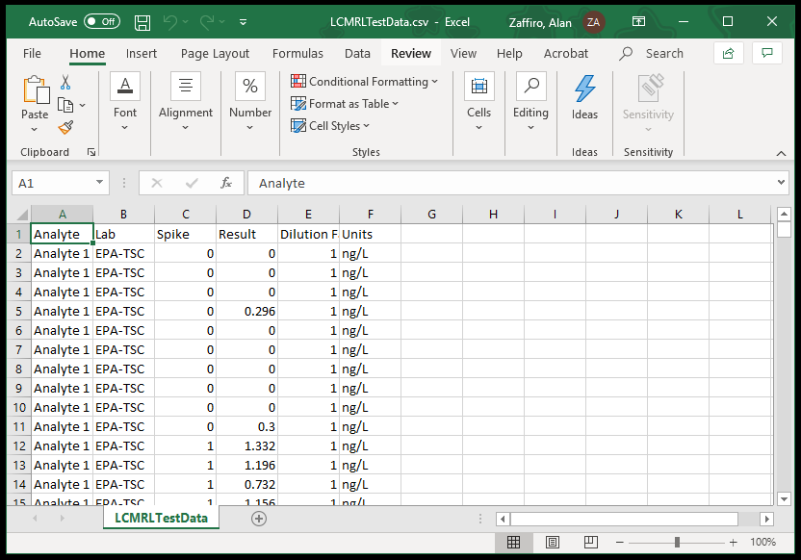

EPA recommends using the test data file embedded in the *LCMRL* package as a template. To access this file, type, or copy and paste, GetTestData()at the command prompt (>) in the RStudio console followed by a carriage return. In the **Browse for Folder** dialog box, create or select a folder to store the test data. The GetTestData() function will write the test data file to this folder under the name, LCMRLTestData.csv.

The following rules apply for data entry:

Header, first row, must use the syntax: "Analyte", "Lab", "Spike", "Result", "Dilution Factor", "Units"

Column Field Description

A Analyte name (alphanumeric; no commas should appear in the name)

B Lab name (alphanumeric; no commas should appear in the name)

C Spiking level (numeric); enter “0” for laboratory reagent blanks (LRBs)

D Measurement (numeric)

E Dilution factor (numeric). Program at this time only expects dilution factors of 1.

F Units of measurement (alphanumeric with no commas)

## Open RStudio and Load the LCMRL Program

Start RStudio. It is not necessary to start R. The RStudio console will appear with a message (version number and disclaimer) followed by a command prompt indicated by “>”(Figure 1).

Each time RStudio is opened, the statistics packages must be activated to load the LCMRL program:

Select the **Packages** tab in the field at the lower right of the RStudio console (Figure 2). Find *lattice* and *LCMRL* in the list and click on the check box for each. A checkmark will appear in the boxes and the RStudio console will display the script library(package) as each package is selected, where package equals *lattice* or *LCMRL* (Figure 2).

## Running LCMRL Scripts using the Default Modeling Parameters – Overview

Experienced users will be able to complete the LCMRL calculations using this summary. Expanded instructions are provided beginning with Section 4.5. For LCMRL data sets that include only positive values, set the ‘rnnr’ variable to ‘1’. Three command lines are required to calculate LCMRLs and generate the graphs, each followed by a carriage return:

fh.labdata<-file.choose()

LCMRL.Values(fh.labdata,rnnr=1)

LCMRL.Graphs(fh.labdata,rnnr=1)

For LCMRL data sets that include negative values, set the ‘rnnr’ variable to ‘0’. Three command lines are required to calculate LCMRLs and generate the graphs, each followed by a carriage return:

fh.labdata<-file.choose()

LCMRL.Values(fh.labdata,rnnr=0)

LCMRL.Graphs(fh.labdata,rnnr=0)

The output files are written to the directory containing the input file.

Note: Enter the scripts into the RStudio console at the command prompt (>) with the exact syntax shown. It is recommended that the user open this help file so that these scripts can be copied and pasted into the RStudio console rather than typing them.

## Expanded Instructions using the Default Modeling Parameters

Type or paste the following script into the RStudio console at the command prompt (>) followed by a carriage return:

fh.labdata<-file.choose()

This script opens a dialog box titled **Select file**. Find and open the input file. A fresh command prompt appears. Type or paste the following LCMRL script followed by a carriage return to calculate LCMRLs:

LCMRL.Values(fh.labdata,rnnr=1)

Use rnnr=0 for data sets with negative values. The RStudio console displays a single-line message as the LCMRL for each analyte is completed, for example, “For: Analyte 1--EPA-TSC”.

### Errors

If the LCMRL program reports an error for one of the analytes, processing will stop at that point. The most likely cause is an incorrect entry or unallowed syntax in the input file. Verify that the input file is correctly formatted as described in Section 4.2 and return to the beginning of this step.

### LCMRL Output File

If no errors occur, the LCMRL program writes a new Microsoft Excel .csv file to the directory containing the input file. The analytes and their LCMRL values are listed in the order they were entered into the input file. When processing is complete for all analytes, the path and name of the output file appear in the RStudio console.

The LCMRL script uses the name of the input file appended by “–LCMRL.Values.” to name the output file. If the name of the user input file is “Method 558.csv”, the LCMRL result file name would be “Method 558–LCMRL.Values.csv”.

Comma separated values (.csv) files are not formatted, and the user must expand the columns to view the full text of the analyte names and the messages in Column G. To retain formatting, save the .csv file as a Microsoft Excel Workbook (.xlsx).

## Expanded Instructions for Generating LCMRL Graphs (Default Modeling Parameters)

### Graphs Script

After R completes the processing for calculating LCMRLs, a fresh command prompt (>) will appear. Type or paste the following script at the command prompt followed by a carriage return to generate the LCMRL graphs:

LCMRL.Graphs(fh.labdata,rnnr=1)

Use rnnr=0 for data sets with negative values. The RStudio console displays a two-line message as each plot is constructed, for example, “For Analyte 3” and “Detection Values for Labs”.

### Output File for LCMRL Graphs

The LCMRL program writes a PDF to the directory containing the input file with two plots for each analyte. After processing is complete for all analytes, the path and name of the output file appear in the RStudio console.

The graphs script uses the name of the input file appended with “–LCMRL.Graphs” to name the output file. If the name of the user input file is “Method 558.csv”, the PDF name would be “Method 558–LCMRL.Graphs.pdf”.

# Advanced LCMRL Functions

The LCMRL script used in these instructions is a contracted form of the full script that calls five default arguments, or modeling parameters. Note that the “rnnr” flag for negative LCMRL values is not considered a modeling parameter. Three of the five modeling parameters define constraints used in the calculation of the LCMRL: LQL, UQL, and CPR. Two define constraints for the calculation of a detection limit based on the theory advanced by Hubaux and Vos (1970): alph and bet.2 The expanded form of the LCMRL script with the default variables inserted for the modeling parameters follows:

LCMRL.Values(fh.labdata,LQL=0.5,UQL=1.5,alph=0.05,bet=0.05,CPR=.99,rnnr=1)

## Changing the LCMRL Modeling Parameters

The LCMRL calculator has the capability to generate LCMRLs using different lower quality limits (LQL), upper quality limits (UQL), and coverage probabilities (CPR) than the default values. This capability has been retained for users who wish to generate LCMRLs consistent with their own data quality objectives and programmatic goals. The LCMRL modeling parameters and the steps for running scripts with alternate modeling parameters are described in the Appendix.

## Modified Hubaux-Vos Detection Limit

The modified Hubaux-Vos Detection Limit (mHV-DL) is defined by EPA as the spiking concentration that has a 95% probability of exceeding the 95% critical level.1 The conditional distributional model constructed for determining the LCMRL is also used to determine the mHV-DL. The LCMRL script generates an mHV-DL for each method analyte and writes it to the same .csv file containing the LCMRL results. The modeling parameters may be altered for the calculation of the mHV-DL as described in the Appendix. The calculated mHV-DLs for the five analytes in the test data included with the *LCMRL* package are given in Table 1.

# Procedure for Collecting LCMRL Data

The LCMRL Procedure requires a minimum of four LFBs at each of seven concentrations, or “spiking levels”. These LFBs, plus a minimum of four LRBs, or “zero spiking level”, are processed through the entire method procedure. All method specified steps, such as sample extraction and sample preservation, must be included.

The following subsections provide detailed instruction for conducting the LCMRL study. An overview is provided here.

Calibrate the analytical instrument. Suggested calibration ranges for the method analytes and concentrations for the internal standards and surrogates can be found in the EPA method.

Start by selecting five spiking levels that will be used to estimate the LCMRL for each analyte. Section 6.2 including subsections discuss criteria useful for determining appropriate concentrations. Make sure each LFB concentration you select is bracketed by calibration standards (Sect. 6.1.2). After you complete five of the seven LFB levels, calculate LCMRLs for the method analytes.

Select at least two more LFB levels. See Section 6.4 for guidelines on appropriate LFB concentrations. As you complete these additional levels, update the LCMRL input file with the additional data and calculate revised LCMRLs. For each analyte, the LCMRL program will display a message in the output file indicating whether a valid LCMRL has been determined or if additional spiking levels are required. Follow the recommendations in Section 6.2.3 (lower level LFB needed) and Section 6.2.4 (higher level LFB needed) to add additional spiking levels until valid LCMRLs are determined for each analyte.

## LCMRL Calibration Range

### Use a Typical Range

The concentration of the highest calibration standard should be consistent with routine analysis. The instrument calibration range should be typical of expected routine sample analysis. The use of an instrument calibration that has an unreasonably narrow range may yield a lower LCMRL, but the LCMRL will not reliably reflect performance during routine analysis. The calibration range must not exceed the response that begins to saturate the detector.

### Range Must Encompass LFB Spiking Levels

The concentration of the LFBs must lie within the range of the calibration. Spiking levels are invalid if their concentration exceeds the calibration range at the low or high end.

## LFB Concentrations Must Bracket LCMRL

The LCMRL must be bracketed by at least one LFB concentration level that is at, or below, the LCMRL and by at least one LFB level that is at, or above, the LCMRL. If this is not the case, then at least one more level of LFBs must be processed to include the LCMRL within the concentration range of the LFBs. An estimate for a low-level spiking concentration might be where the mean of replicates is close to the accuracy extremes of 50 and 150% or where reproducibility begins to break down. When interferences are present, one might use a low-level estimate of twice the equivalent concentration of the analyte peak as found in the method blank. The accuracy and precision for data lower than the LCMRL may be of poor quality, but it is necessary to find at what concentration data quality begins to break down.

### Range of LFB Concentrations

It is recommended that the range of LFB concentrations be within about a factor of twenty of the LCMRL. Spiking levels that far exceed the LCMRL lose significance when estimating an LCMRL. More than seven levels of LFBs may be needed to observe this recommendation for multi-analyte methods.

### Counting LFB Levels

For each analyte, three of the four analyses in each spiking level must be reported as non-zero results or that level does not count toward the required seven LFB levels. LRBs do not count as one of the required seven spiking levels.

### When LCMRL Estimate is Less than the Lowest LFB Concentration

When the calculated LCMRL is lower than the lowest LFB spiking level, an estimated LCMRL result will appear in the output file with a message: “Lower spiking level needed to bracket the LCMRL.” This means that the LCMRL program needs a lower LFB level to calculate a valid LCMRL. Fortify this additional LFB below the estimated LCMRL while retaining as much signal to noise as possible. Practically speaking, at least one spiking level must fail LCMRL QC limits to determine an LCMRL.

If the lower spiking level is below the current calibration range, a calibration standard must be added at, or below, the concentration of the added LFB. Run a full calibration with the new standard included. The additional low-level calibration standard may fail the method QC limits for calibration, but this calibration level should be allowed so that the LCMRL calculator can determine an LCMRL. Completed LFB levels do not have to be re-analyzed.

### When LCMRL Estimate is Greater than the Highest LFB Concentration

When the calculator determines that an LCMRL estimate is higher than the highest LFB spiking level, an LCMRL result will not appear in the output file. Instead, this message will appear: “LCMRL is above highest spiking level”. This means that when the calculator processed the LFB results, the LCMRL QC probability limits were greater than 50 to 150%, even at the highest level. If an LCMRL is to be determined, a higher LFB level must be processed. This assumes that accuracy and precision will improve at higher spiking levels. For example, if the method cannot extract at least a recovery of 50% at any concentration, an LCMRL defined as “between 50 and 150% recovery” cannot be determined. At least one spiking level needs to pass LCMRL QC probability limits to determine an acceptable LCMRL.

If the higher spiking level exceeds the current calibration range, a calibration standard must be added at, or above, the concentration of the added LFB. Run a full calibration with the new standard included. Completed LFB levels do not have to be re-analyzed.

### Running Out of Response

If the calculated LCMRL is below the lowest LFB concentration and data cannot be obtained below the LCMRL, then the laboratory should set the LCMRL at the lowest LFB concentration.

## Include Laboratory Reagent Blanks in Data Set

At least four LRBs must be included in the dataset. If the LRB does not have a response, report “0”.

## Estimate LCMRL after Five Spiking Levels

It is recommended to calculate the LCMRL after the first five spiking levels have been processed so that the next two LFB concentrations can be selected based on the estimated LCMRL. A lower or higher concentration may be needed to ensure the LCMRL is bracketed by LFBs. If the estimated LCMRL is already bracketed, select additional concentrations within the existing range, or expand the range at either end keeping the LFB concentrations as close as possible to the estimated LCMRL.

## Outliers

Extreme data observations, or outliers, can occur. An outlier may represent the actual lack of reproducibility of the method at that concentration. Or, an outlier may result from changed conditions that represent a different population of data. Or, an outlier may due to analyst error. If the reason for an outlier is known, such as a double spike, that data should not be used. Otherwise, the data should be used. Extreme outliers are down-weighted by the LCMRL calculator.

## Formatting Conventions for Data

### Numerical Results

At least three significant figures for each non-zero result should be reported for LFB and LRB samples and entered into the LCMRL input file. Otherwise, the variance may be censored, resulting in an artificially low LCMRL. Because data systems may truncate the number of digits at the low end of the calibration curve, this requirement may need to be addressed by selecting a lower set of units for the LCMRL analyses. Note that numerical results ending in zero are truncated in .csv files. For example, a result of 4.00 ng/L would appear in the .csv input file truncated as “4”. This is normal and does not affect the calculation.

### Report No Response as Zero

Instrument software may not report a result when there is not a peak to integrate. Report such an analysis as “0”. In addition, when a software system reports “below calibration,” enter “0”.

### Negative Values

At low-level concentration, some instrument software systems will report negative numbers. Enter negative values into the input file and calculate LCMRLs using the script for data sets that include negative numbers (Sect. 4.4).

## No Time Requirement

The LCMRL procedure does not have a time requirement for LFBs to be processed and analyzed. The LFBs can be processed all at once or over time.

## Confidence Level and Data Quality Interval

A reporting level is defined in terms of level of confidence and data quality. The 99% confidence level that is used for the prediction interval is considered conservative, but for drinking water surveys the quality of the data is important. The data quality interval that was chosen for the LCMRL, 50 to 150%, was based upon the judgment of experienced analysts at OGWDW.

# References

1. US EPA. *Technical Basis for the Lowest Concentration Minimum Reporting Level (LCMRL) Calculator*; EPA 815-R-11-001; Office of Water: Cincinnati, OH, December 2010.
2. Hubaux, A. and G. Vos. Decision and Detection Limits for Linear Calibration Curves. *Analytical Chemistry* **1970**, Vol. 42, No. 8, pp. 849-855.

# Tables

Table 1. LCMRL Results for the Test Data, ng/L

| Analyte | LFB Spiking Levels1 | LCMRL | mHV-DL2 | Message |
| --- | --- | --- | --- | --- |
| Analyte 1--EPA-TSC | 1.0, 2.0, 4.0, 6.0, 10, 14, 20 | 1.6 | 0.78 | Valid LCMRL |
| Analyte 1--EPA-TSC | 2.0, 4.0, 6.0, 10, 14, 20 | 1.3 | 0.72 | Lower spiking level needed to bracket the LCMRL |
| Analyte 1--EPA-TSC | 1.0, 2.0, 4.0, 6.0, 10, 14, 20 | 3.4 | 1.2 | Valid LCMRL |
| Analyte 1--EPA-TSC | 1.0, 2.0, 4.0, 6.0, 10 | 0 | 0 | LCMRL is above highest spiking level |
| Analyte 1--EPA-TSC | 4.0, 6.0, 10, 14, 20, 41, 82 | 16 | 4.4 | Valid LCMRL |

1. LFB = Laboratory Fortified Blank
2. mHV-DL = Modified Hubaux-Vos Detection Limit

# Figures

Figure 1. RStudio Console showing the Packages Tab

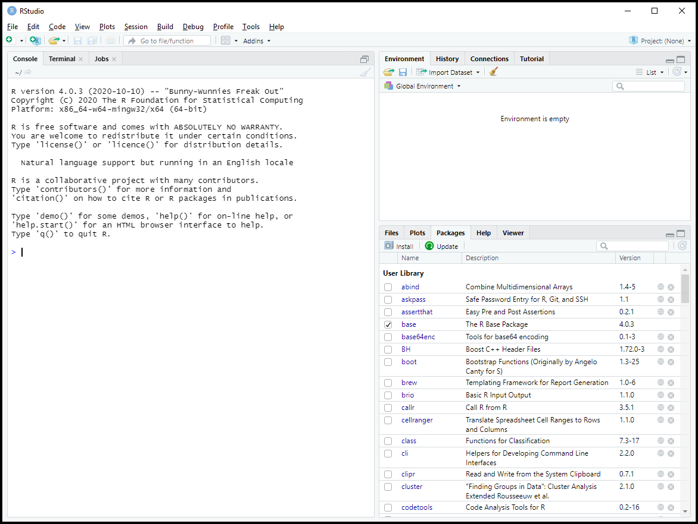

Figure 2. RStudio Console with Packages lattice and LCMRL Activated

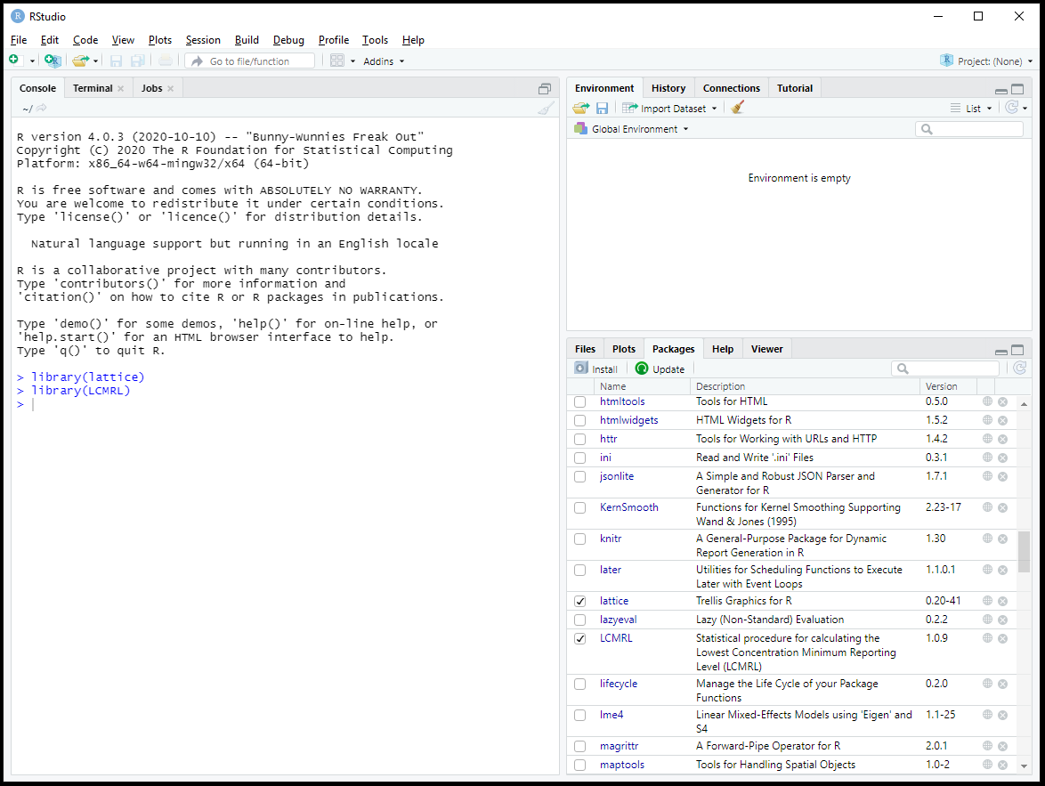

Figure 3. Appearance of the Console after Calculating LCMRLs for the Test Data

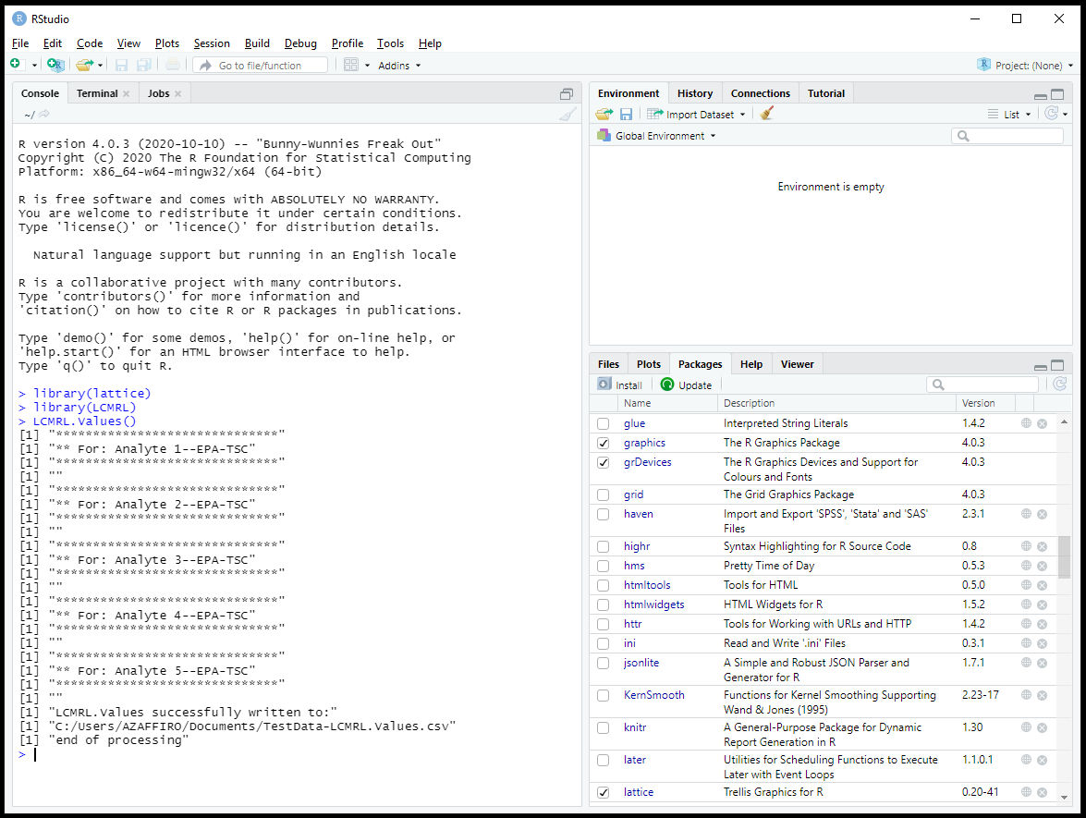

Figure 4. Appearance of the Console after Printing Graphs for the Test Data

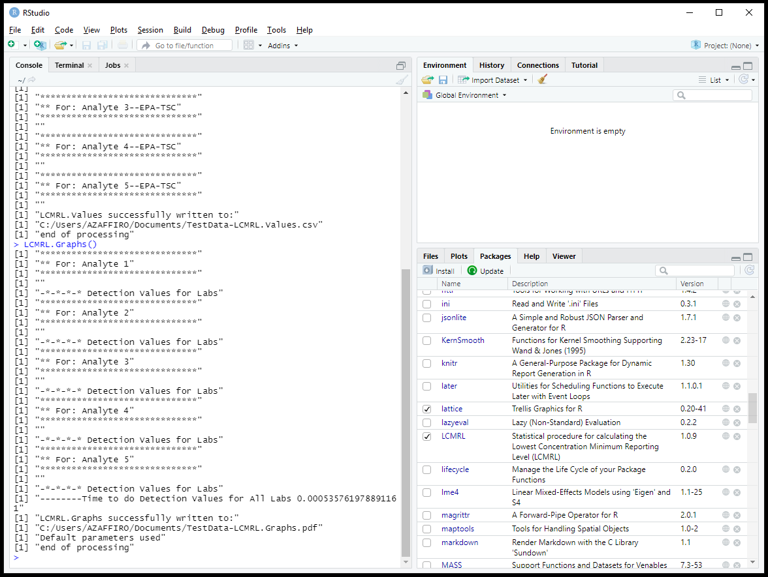

Figure 5. Correct Appearance of the LCMRL Graphs for the Test Data

Correct Appearance of the LCMRL Graphs  for the Test Data.Correct Appearance of the LCMRL Graphs  for the Test Data.

Figure 6. Correct Appearance of the LCMRL Graphs for the Test Data (cont.)

Correct Appearance of the LCMRL Graphs  for the Test Data.Correct Appearance of the LCMRL Graphs  for the Test Data.

Figure 7. Correct Appearance of the LCMRL Graphs for the Test Data (cont.)

Correct Appearance of the LCMRL Graphs  for the Test Data.Correct Appearance of the LCMRL Graphs  for the Test Data.

Figure 8. Correct Appearance of the LCMRL Graphs for the Test Data (cont.)

Correct Appearance of the LCMRL Graphs  for the Test Data.Correct Appearance of the LCMRL Graphs  for the Test Data.

# Appendix: Alternate Modeling Parameters

The procedure for collecting LCMRL data (Sect. 6) and formatting the input file (Sect. 4.2) are identical to the procedure using the default parameters. Users should consult the technical basis document1 available on EPA’s LCMRL webpage to gain an understanding of the statistical significance of the modeling parameters.

## Modeling Parameters, Default Values, and Input Ranges

LQL Lower Quality Limit default is 0.5. Can be reset to a value between 0 and 1.

UQL Upper Quality Limit default is 1.5. Can be reset to a value between 1 and 2.

CPR Coverage Probability default is 0.99. Can be reset to a value between 0 and 1.

alph Alpha value for the mHV-DL with a default of 0.05. Can be reset to a value between 0 and 1.

bet Beta value for the mHV-DL with a default of 0.05. Can be reset to a value between 0 and 1.

rnnr Required Non-Negative Response flag. The default for the rnnr flag is 1.

For the rnnr flag, use 1 for LCMRL data with only positive values and 0 if the data set includes negative values. The Alpha and Beta values apply only to the calculation of the modified Hubaux-Vos detection limit (mHV-DL).

## Running LCMRL Scripts with Modeling Parameter Arguments

For LCMRL data sets that include only positive values, set the ‘rnnr’ variable to ‘1’. Three command lines are required to calculate LCMRLs and generate the graphs, each followed by a carriage return. For the following scripts, the default parameters are inserted:

fh.labdata<-file.choose()

LCMRL.Values(fh.labdata,LQL=0.5,UQL=1.5,alph=0.05,bet=0.05,CPR=.99,rnnr=1)

LCMRL.Graphs(fh.labdata,LQL=0.5,UQL=1.5,alph=0.05,bet=0.05,CPR=.99,rnnr=1)

For LCMRL data sets that include negative values, set the ‘rnnr’ variable to ‘0’. Three command lines are required to calculate LCMRLs and generate the graphs, each followed by a carriage return. For the following scripts, the default parameters are inserted (with the exception of rnnr).

fh.labdata<-file.choose()

LCMRL.Values(fh.labdata,LQL=0.5,UQL=1.5,alph=0.05,bet=0.05,CPR=.99,rnnr=0)

LCMRL.Graphs(fh.labdata,LQL=0.5,UQL=1.5,alph=0.05,bet=0.05,CPR=.99,rnnr=0)

The output files are written to the directory containing the input file.

Note: Enter the scripts into the RStudio console at the command prompt with the exact syntax shown. It is recommended that the user open this help file so that these scripts can be copied and pasted into the RStudio console rather than typing them. The LCMRL.Values() and LCMRL.Graphs() scripts above can be pasted into the RStudio console and the default values changed prior to the carriage return which executes the function. For example, the following scripts run the LCMRL dataset with the default parameters reset so that LQL and UQL are 40% and 160%, Alpha and Beta are 0.10 and CPR is 95%, with the Required Non-Negative Response flag turned off:

fh.labdata<-file.choose()

LCMRL.Values(fh.labdata,LQL=0.4,UQL=1.6,alph=0.1,bet=0.1,CPR=.95,rnnr=0)

LCMRL.Graphs(fh.labdata,LQL=0.4,UQL=1.6,alph=0.1,bet=0.1,CPR=.95,rnnr=0)